1. Daily Notes with index
2. Interview questions and answers
3. Difference
4. Different programs to learn operators in java
   1. Arithmetic
   2. Relational
   3. Logical

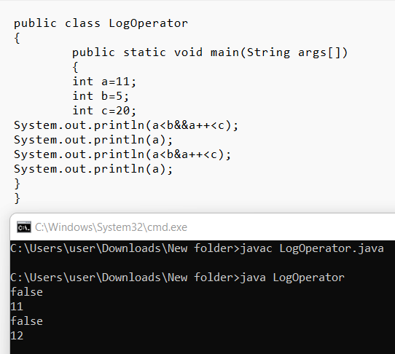

* 1. Assignment

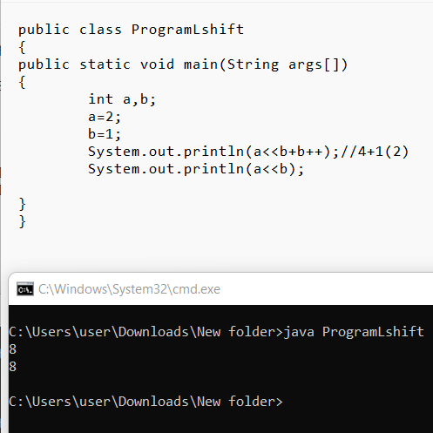

* 1. Unary

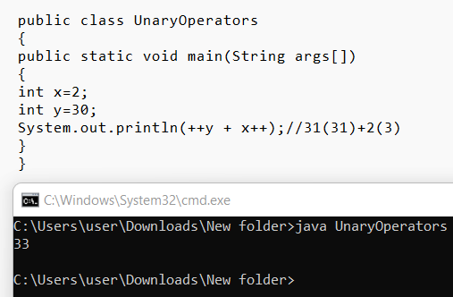

* 1. Shift

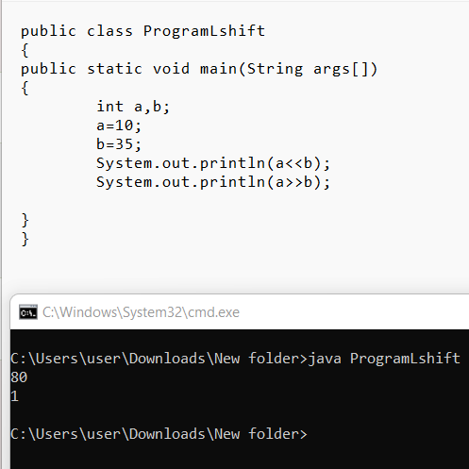

* 1. Bitwise

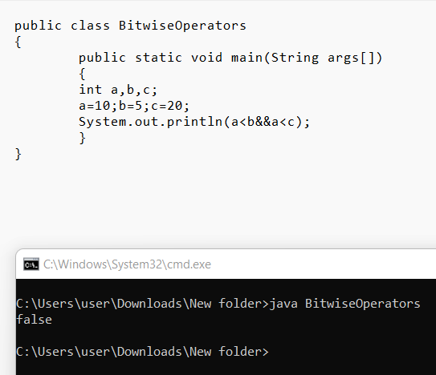

1. Write a program to   
   a) add two integer numbers

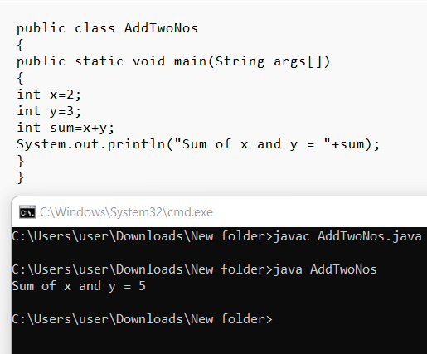

b) add one float number and one integer number

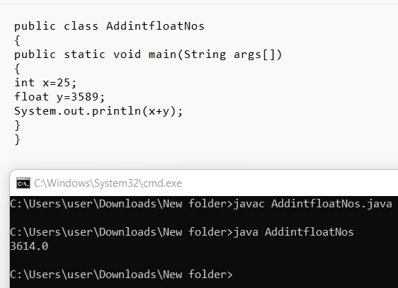

1. Write a program to swap two numbers with temporary variable. Print the numbers before and after swap.

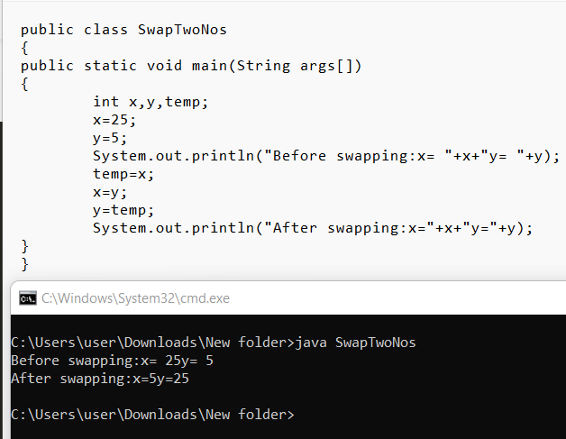

1. Write a program to swap two numbers „without‟ temporary variable. Print the numbers before and after swap.

